

**CAPSTONE PROJECT REPORT**

**Report 4 – Software Design Document**

**Team Coders**

– Ho Chi Minh, January 2024 –

**Table of Contents**

I. Record of Changes 3

II. Software Design Document 4

1. System Design 4

2. Database Design 5

3. Detailed Design 6

3.1 Class Diagram 6

3.2 Activity Diagram 7

3.3 Sequence Diagram 14

3.4 State Diagram 22

# I. Record of Changes

| **Date** | **A* M, D** | **In charge** | **Change Description** |
| --- | --- | --- | --- |
| January 29, 2024 | A | Phan Hiếu Nghĩa | Add section 1 and 2 |
| February 16, 2024 | A | Võ Thanh Tuyền | Add section 3 |
| February 21, 2024 | M | Võ Thanh Tuyền | Modified section 3.2 |
| March 01, 2024 | A | Võ Thanh Tuyền | Add section 3.3 |
| March 08, 2024 | M | Võ Thanh Tuyền | Modified section 3.3 |
| March 09, 2024 | M, A | Võ Thanh Tuyền | Modified section 1 and 2 (update Database)  Add section 3.4 |
| March 12, 2024 | M | Võ Thanh Tuyền | Modified section 3.4 |
|  |  |  |  |
|  |  |  |  |
|  |  |  |  |
|  |  |  |  |
|  |  |  |  |
|  |  |  |  |

*A - Added M - Modified D - Deleted

# II. Software Design Document

## 1. System Design

### 

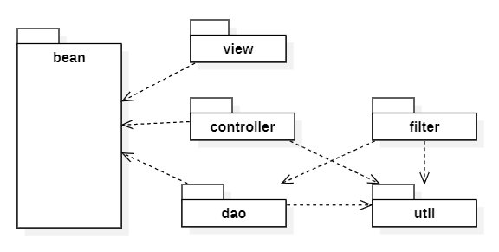

## 2. Database Design

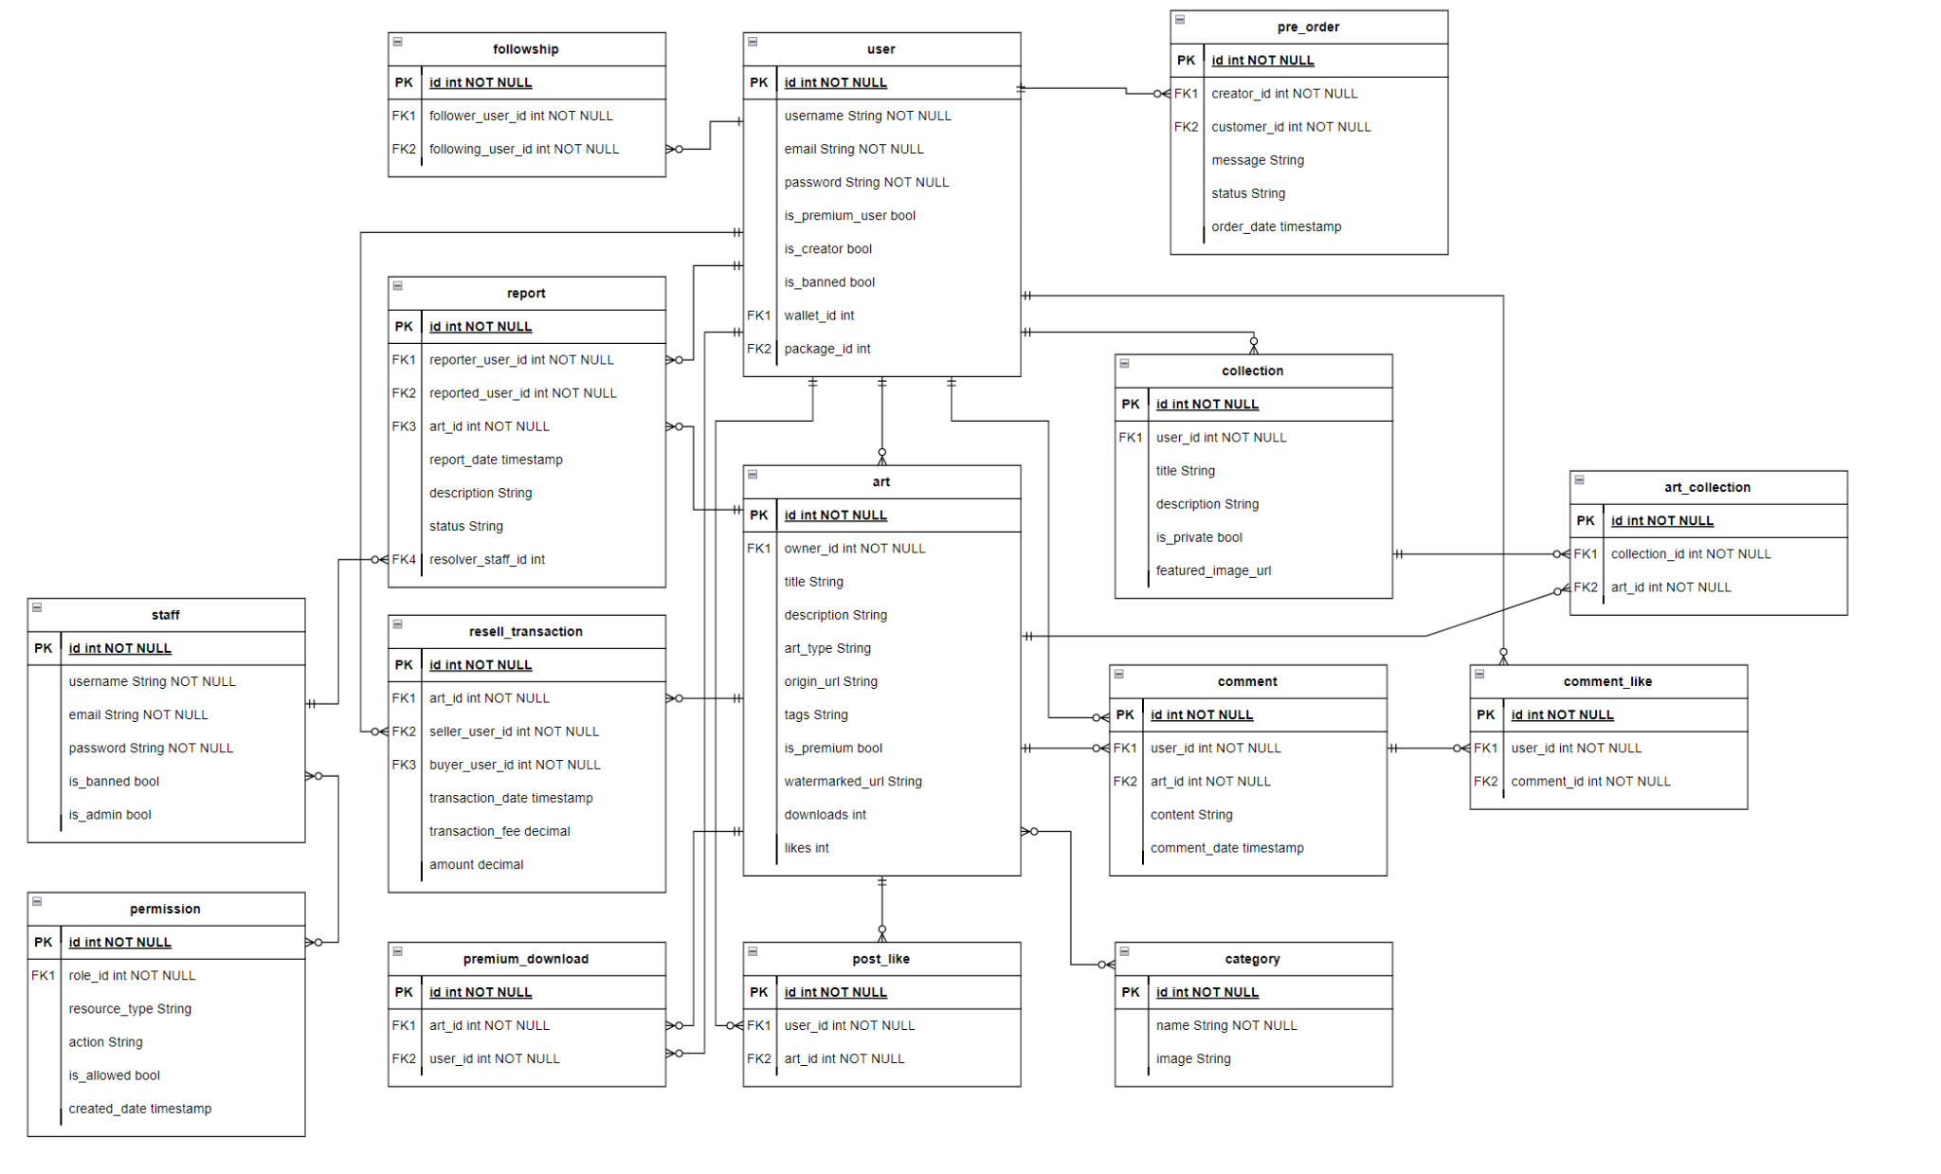

## 3. Detailed Design

### 3.1 Class Diagram

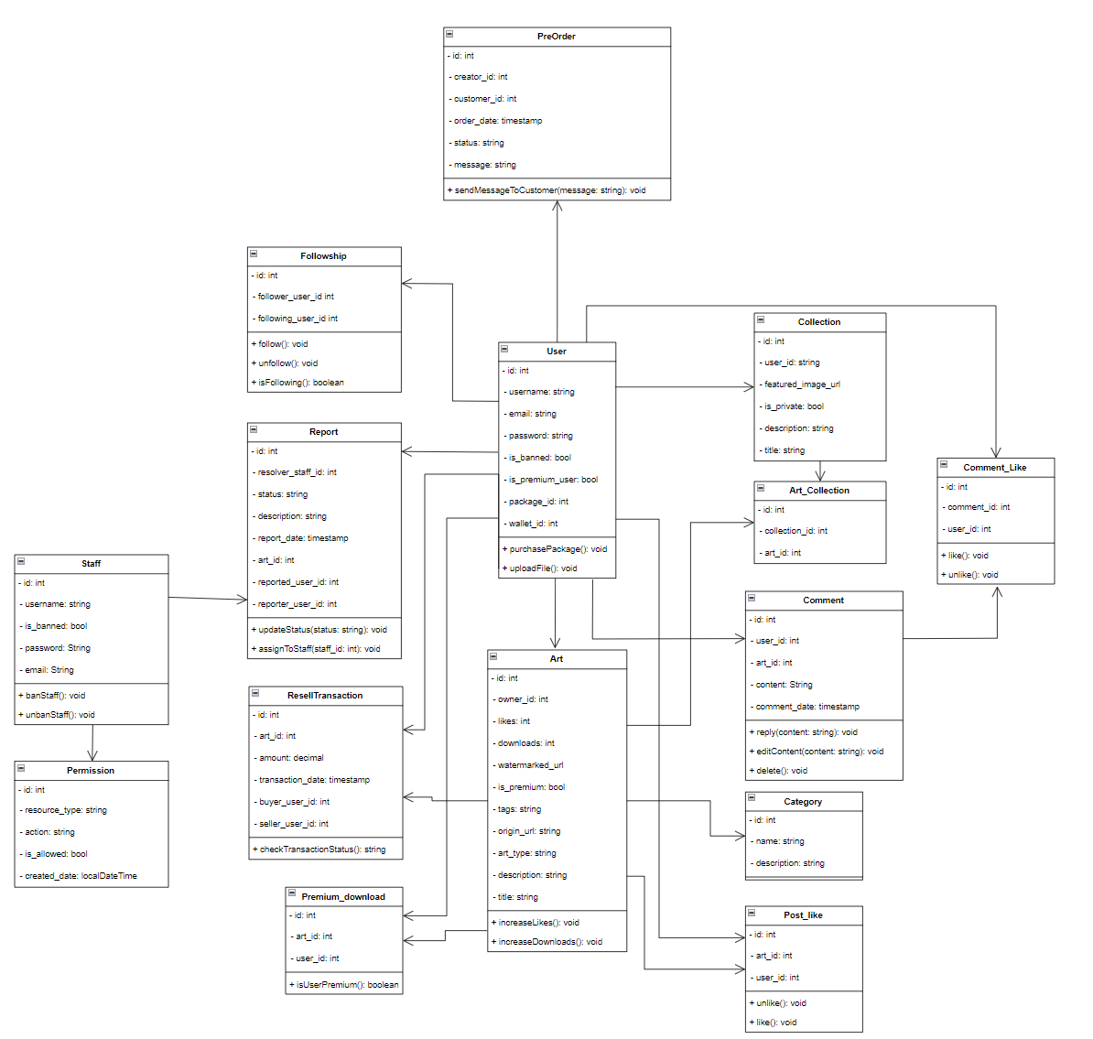

### 3.2 Activity Diagram

#### 3.2.1 Report Creator

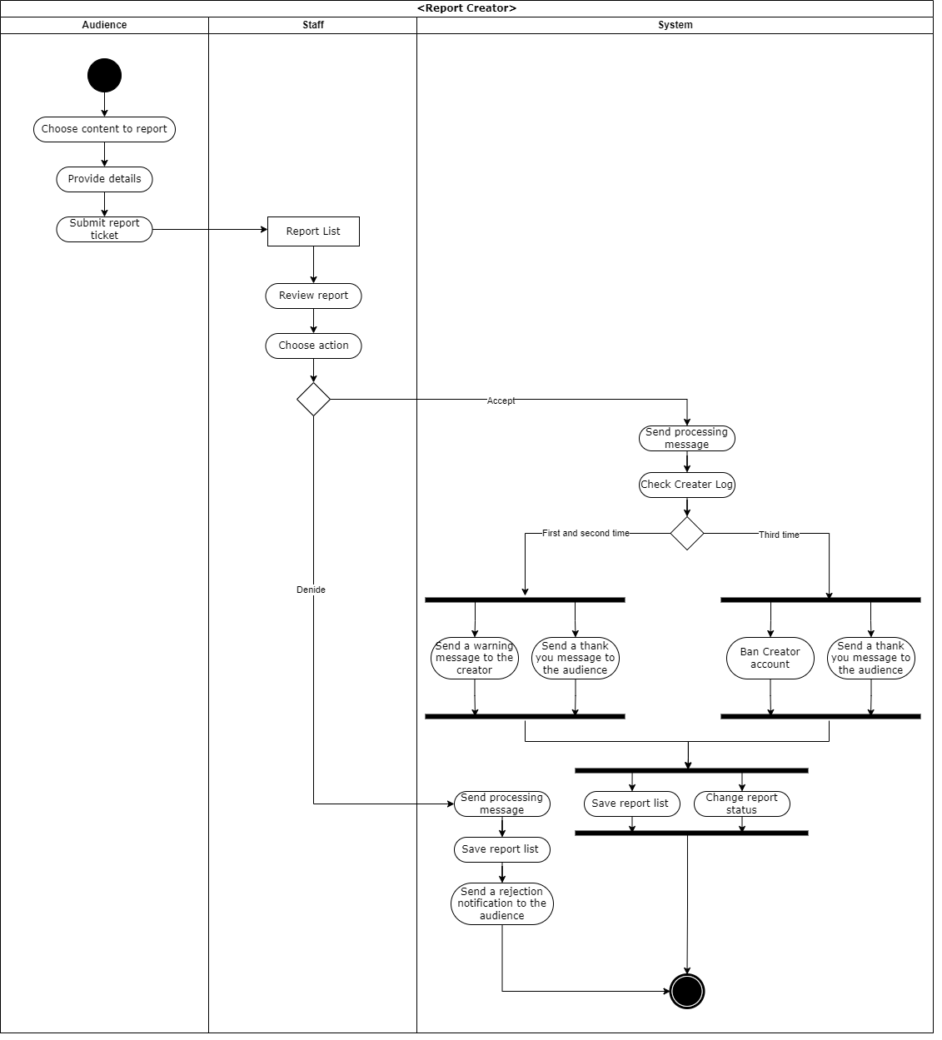

#### 3.2.2 Buy Package

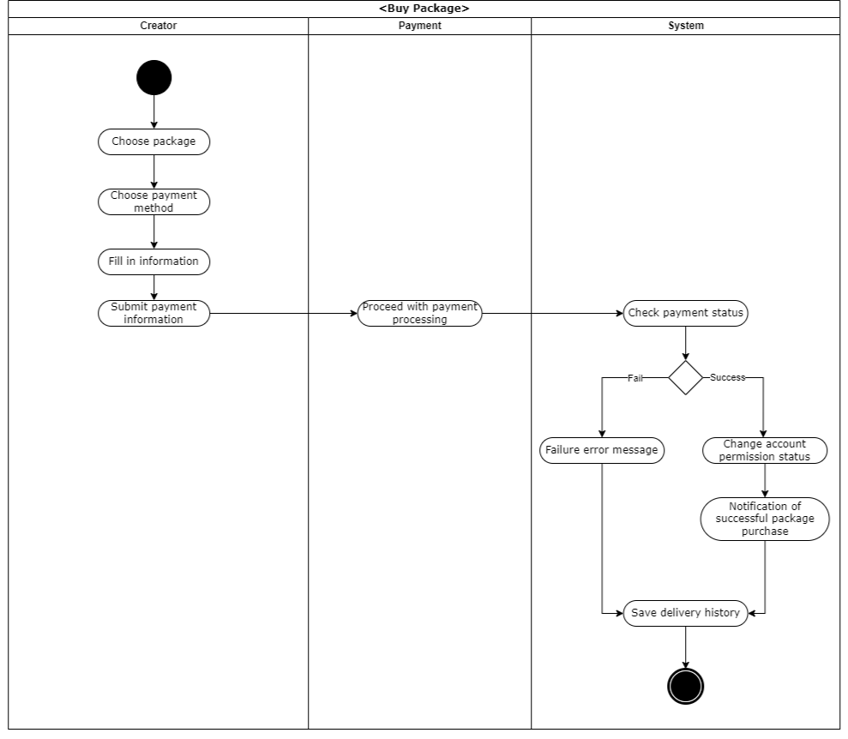

#### 3.2.3 Follow Creator

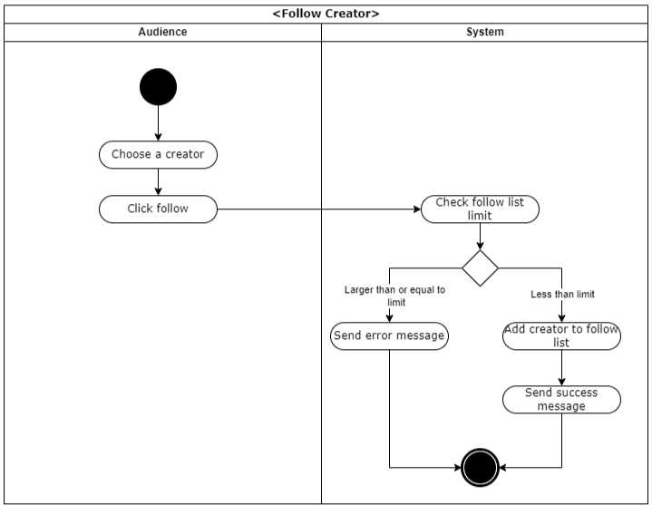

#### 3.2.4 PreOrder Physical Art

#### 3.2.5 Art Posting Process

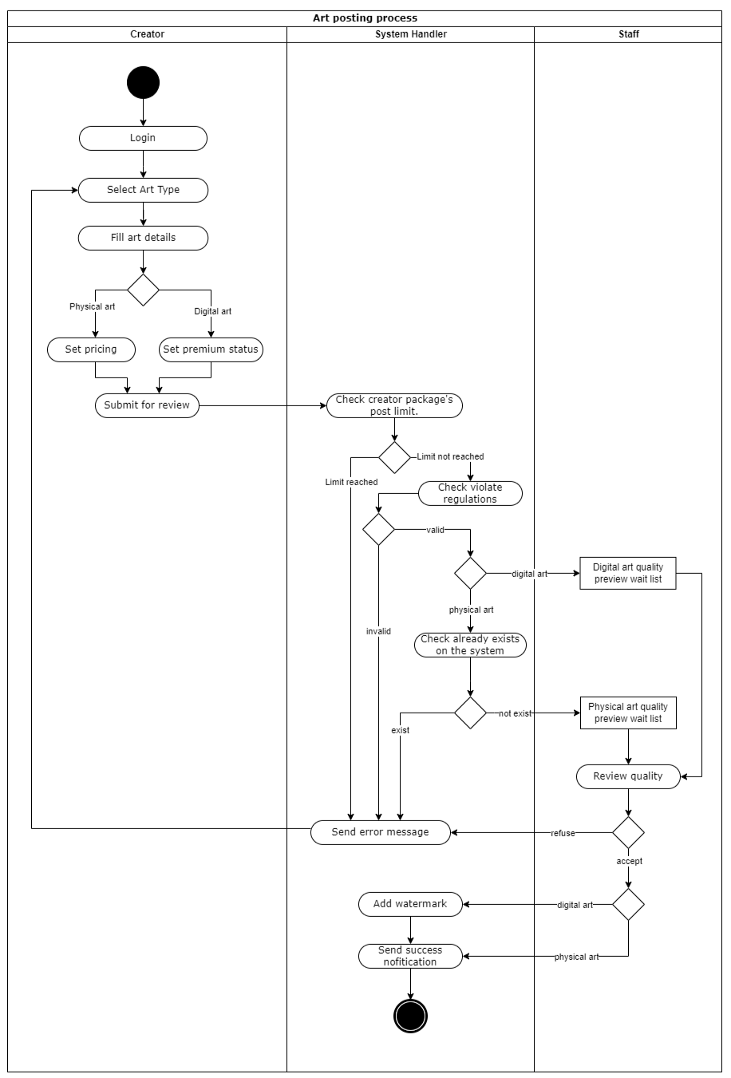

#### 3.2.6 Resell Physical Art Process

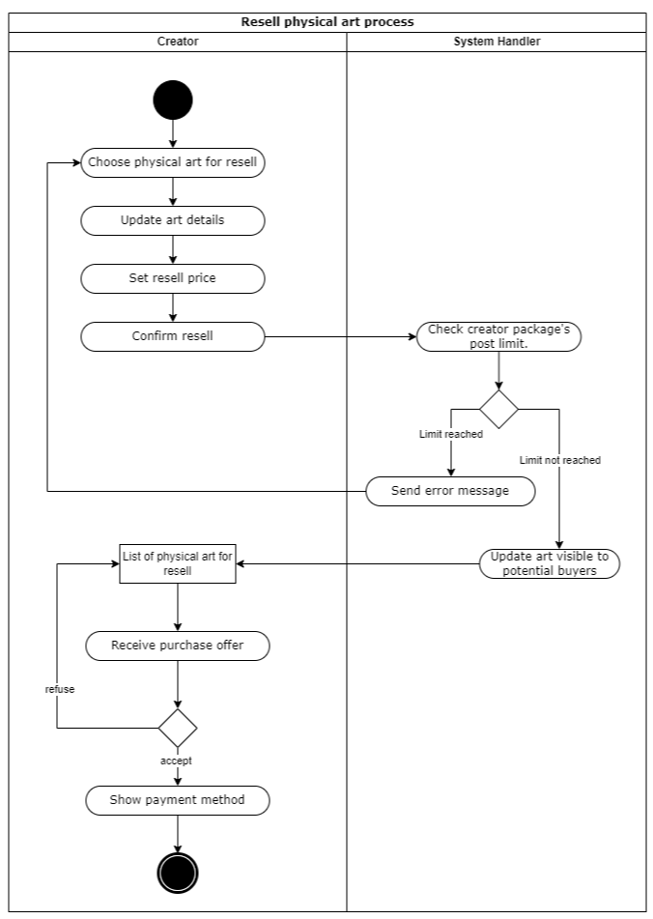

#### 3.2.7 Purchase Process

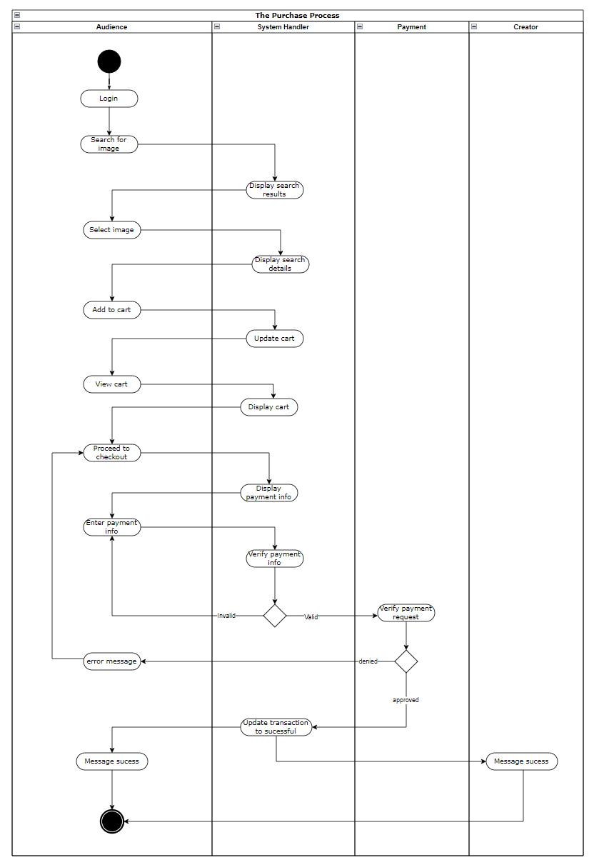

### 3.3 Sequence Diagram

#### 3.3.1 Audience Report Creator

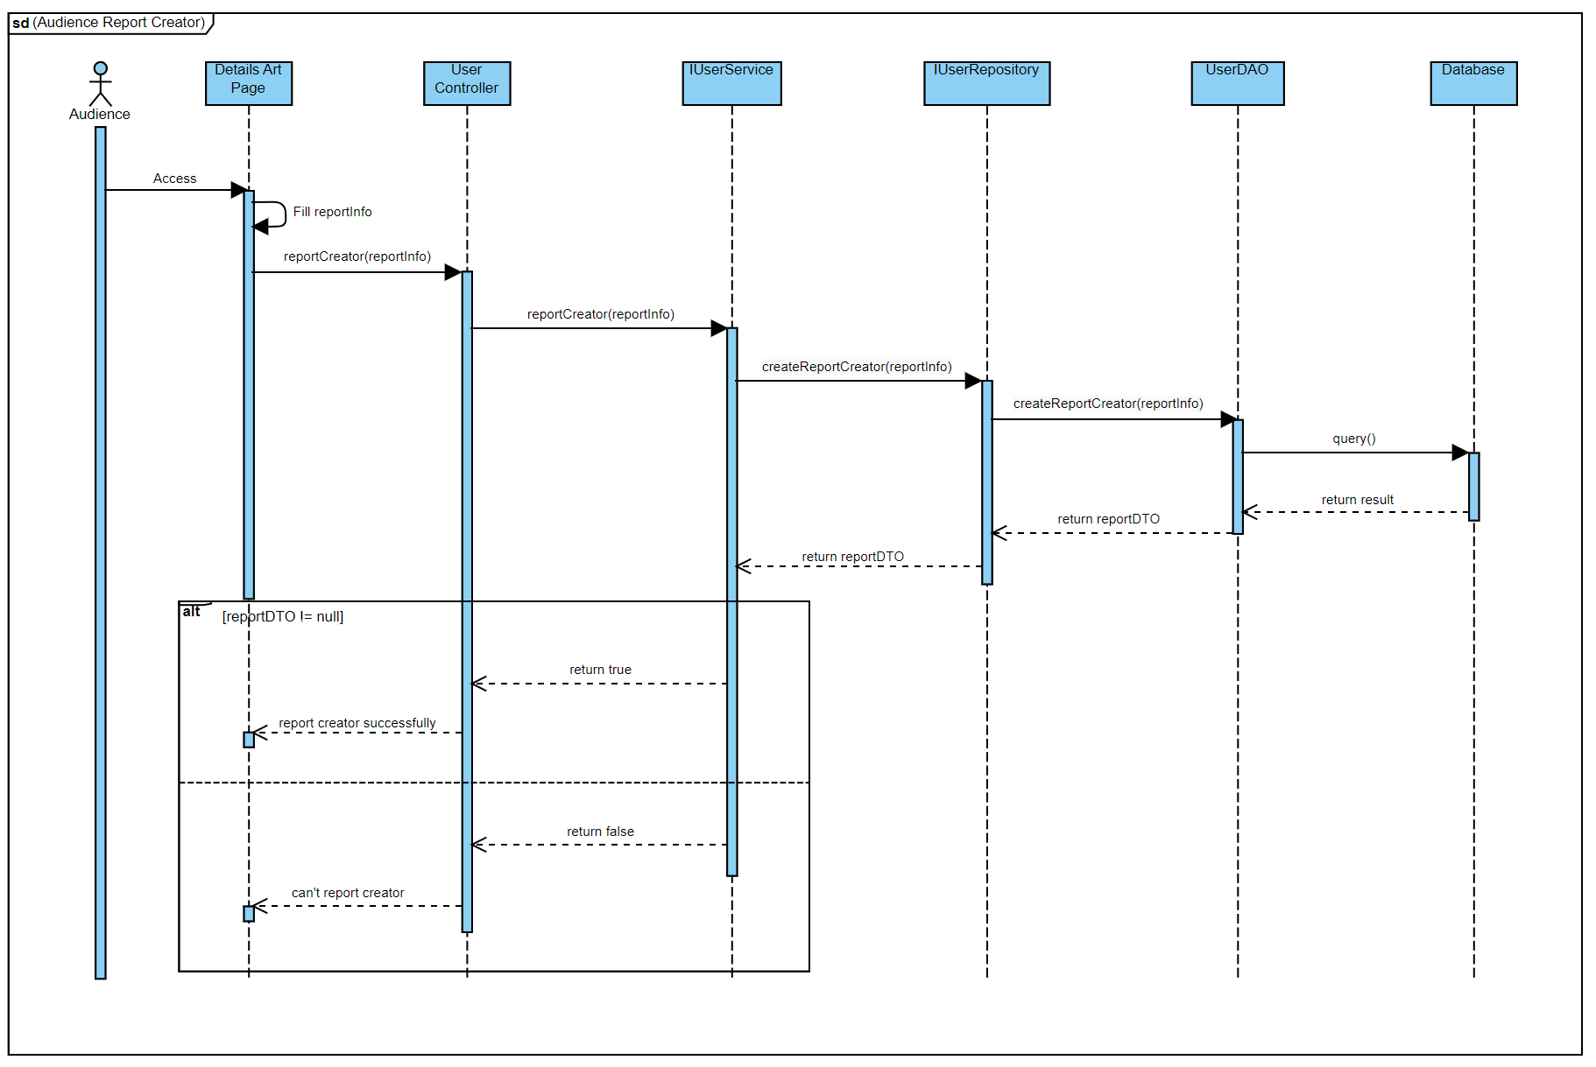

#### 3.3.2 Staff Review Report

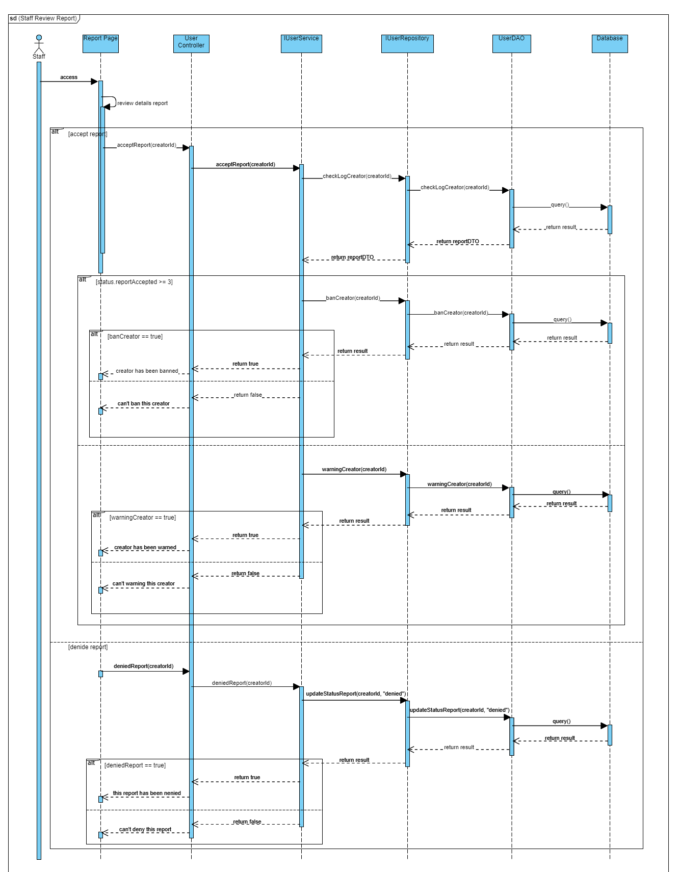

#### 3.3.3 Buy Package

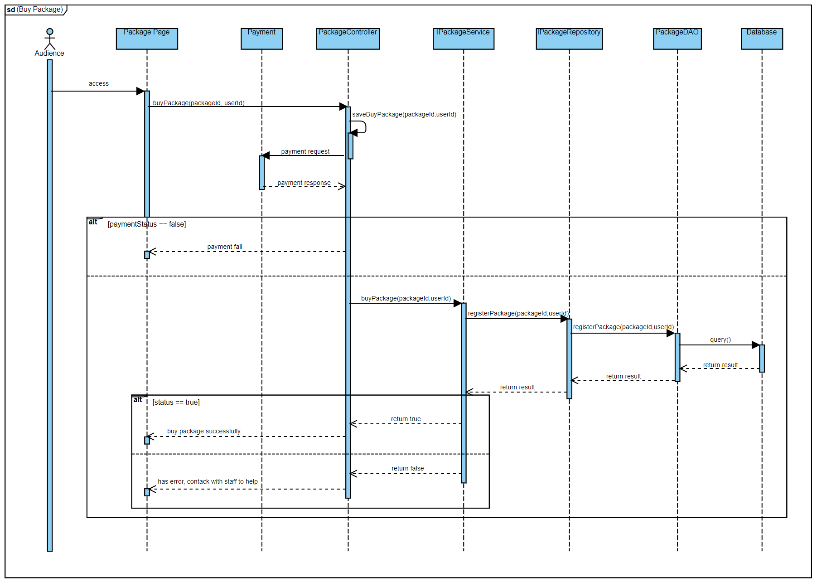

#### 3.3.4 Audience PreOrder Physical Art

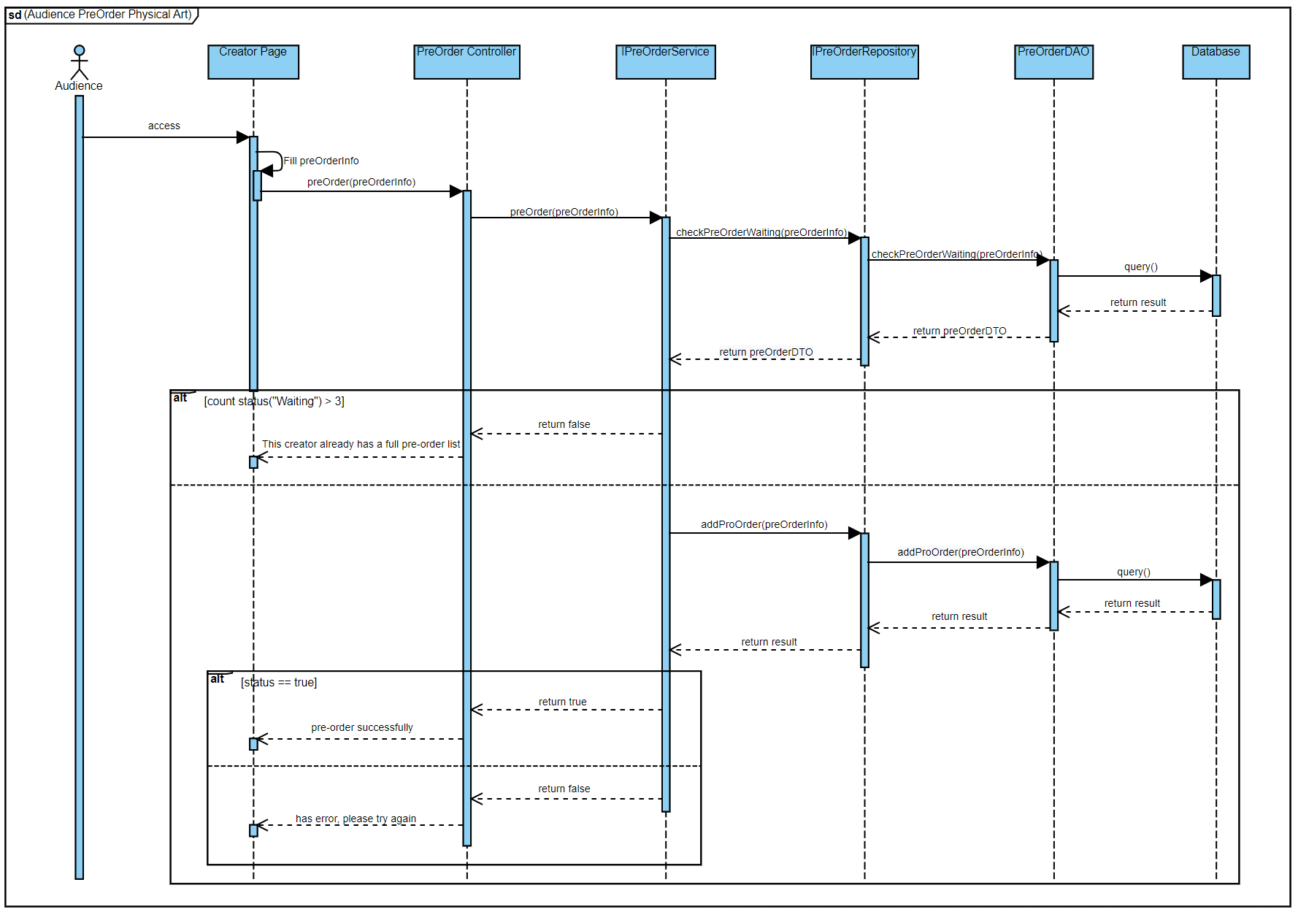

#### 3.3.5 Creator Review ProOrder

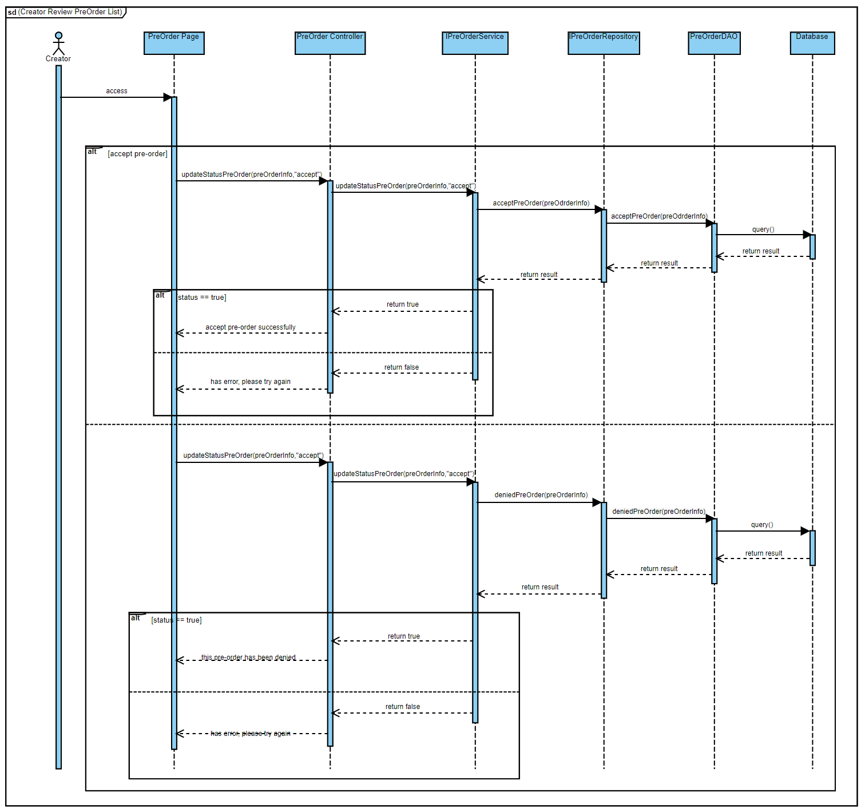

#### 3.3.6 Creator Art Posting Process

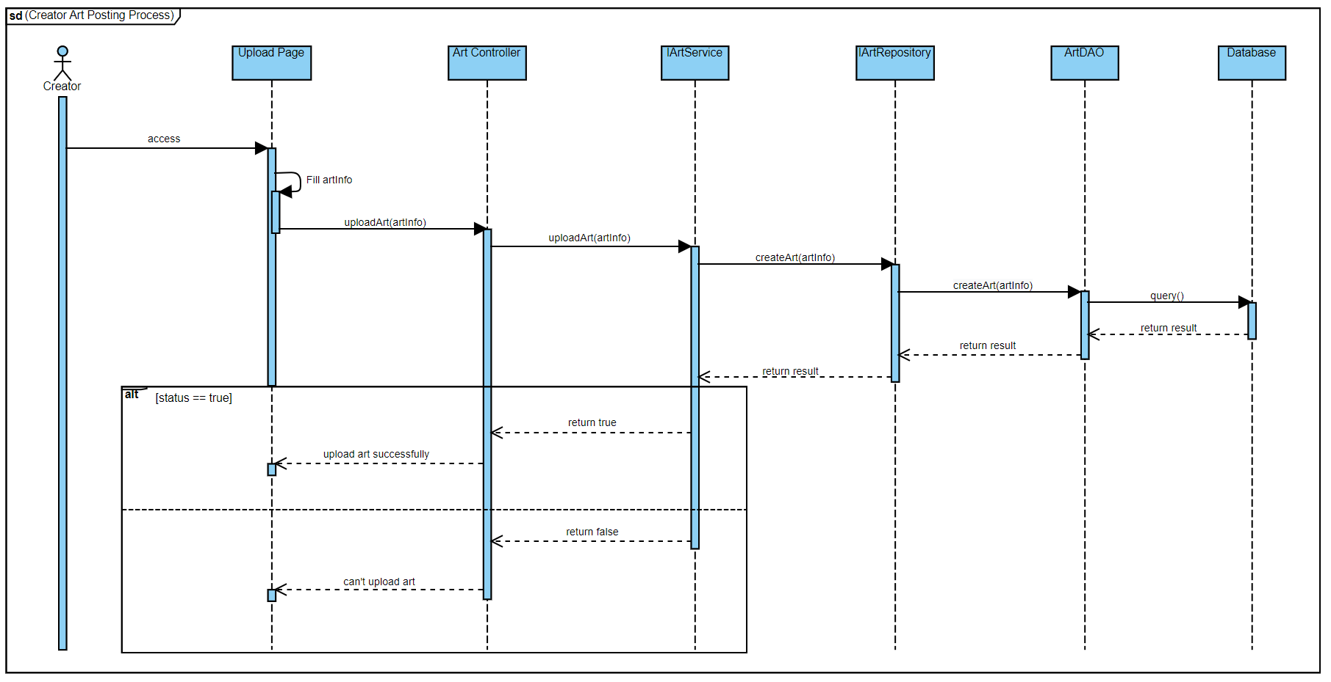

#### 3.3.7 Staff Review Art Posting

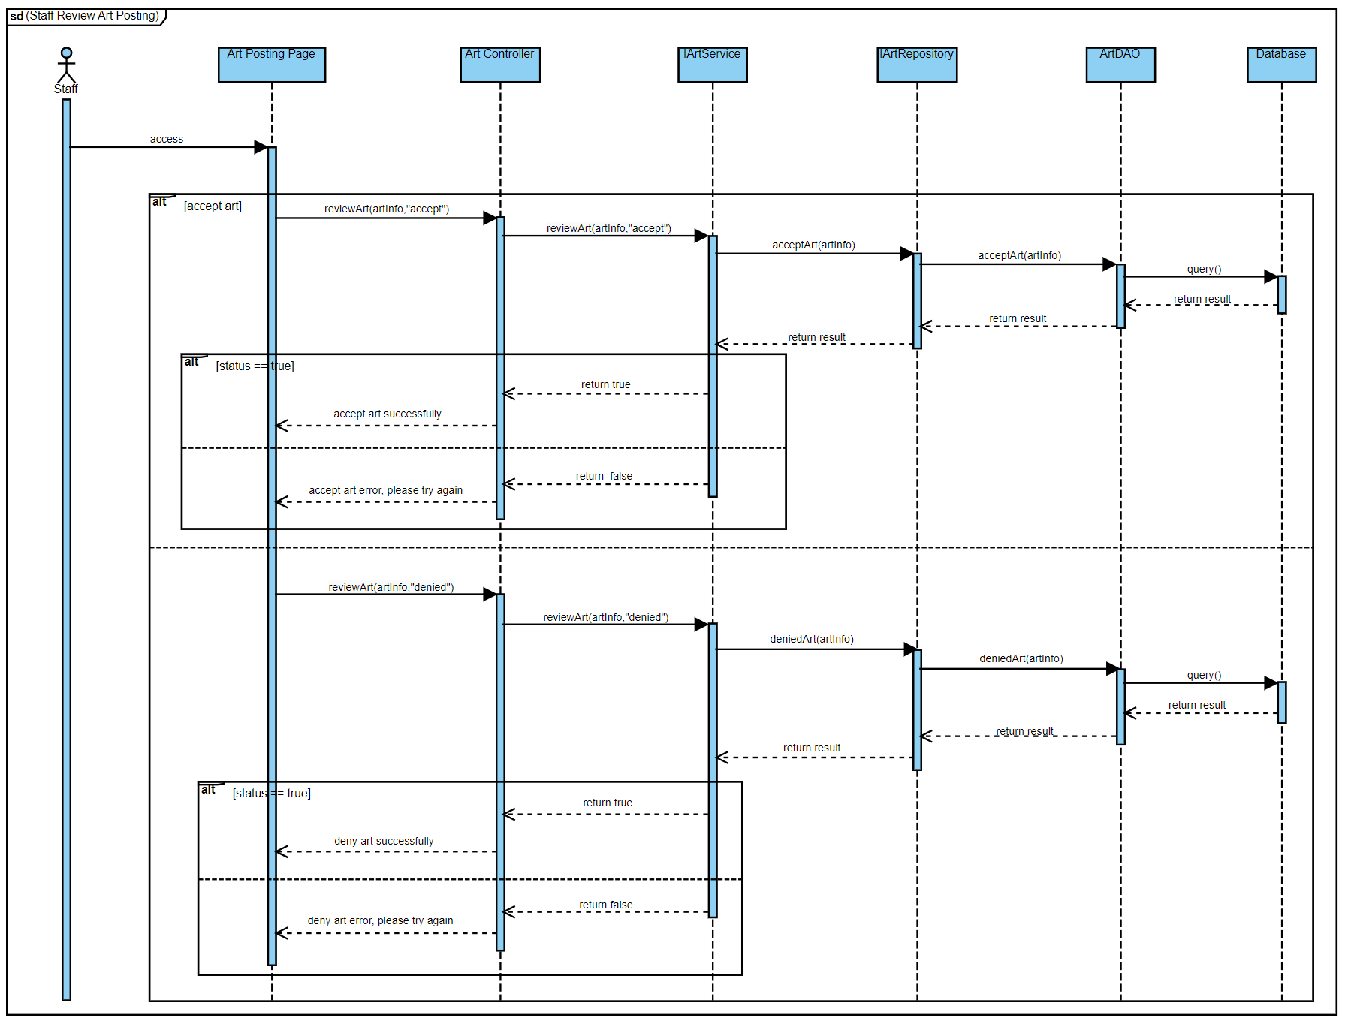

#### 3.3.8 *Resell Physical Art Process*

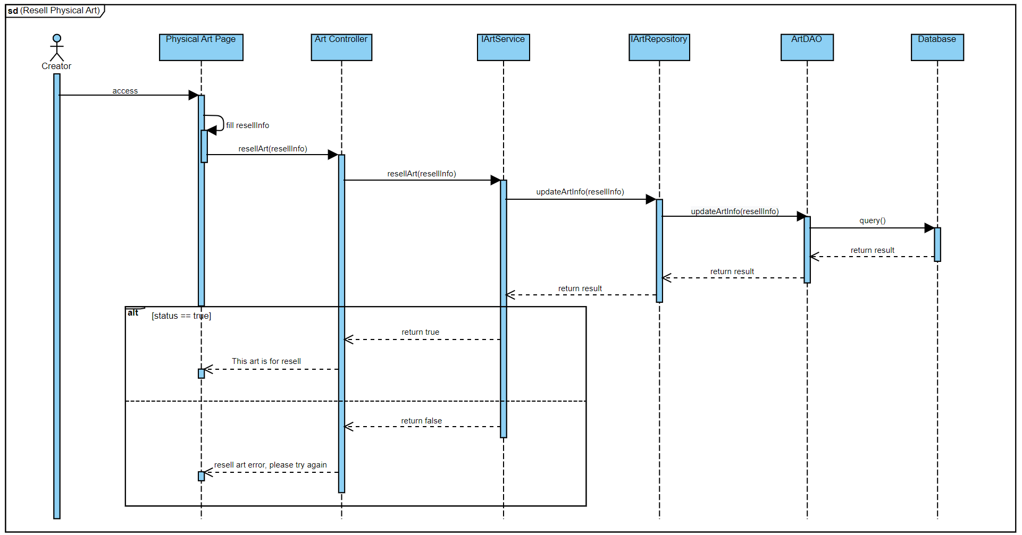

#### 3.3.9 Follow Creator

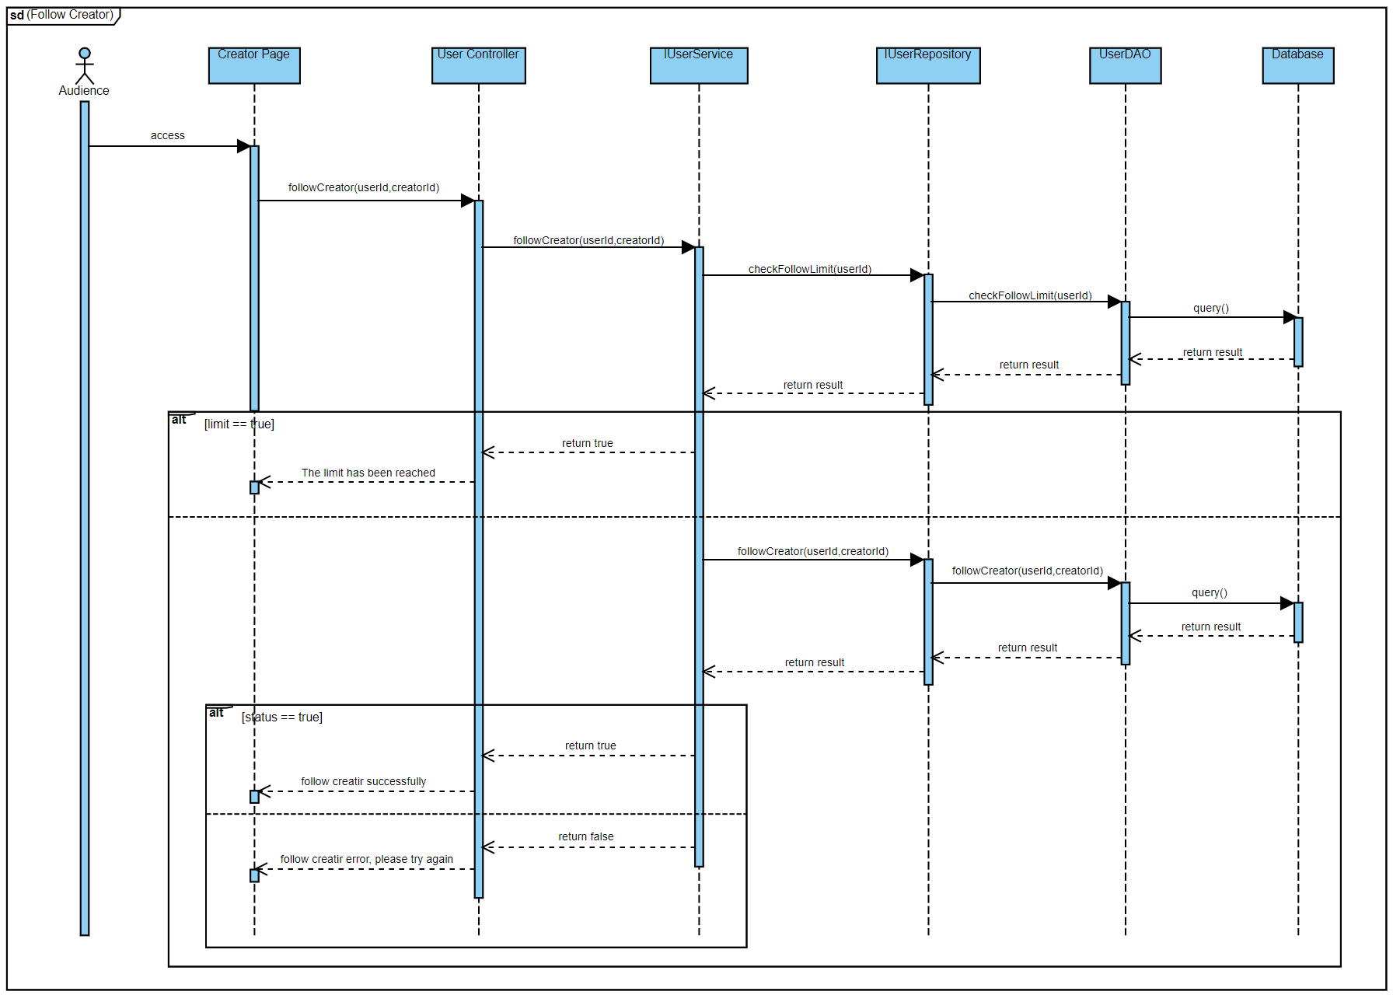

#### 3.3.10 Post Like

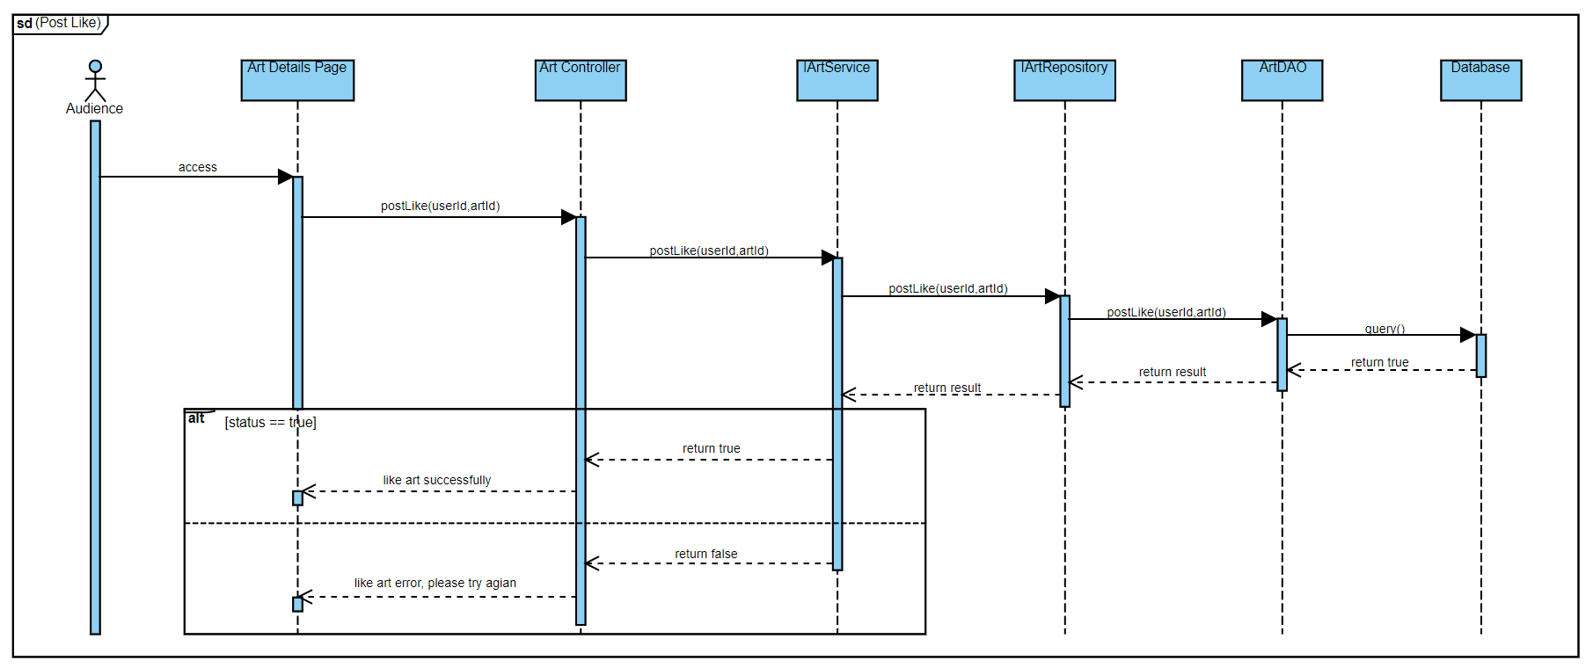

### 3.4 State Diagram

#### 3.4.1 Audience Report Creator

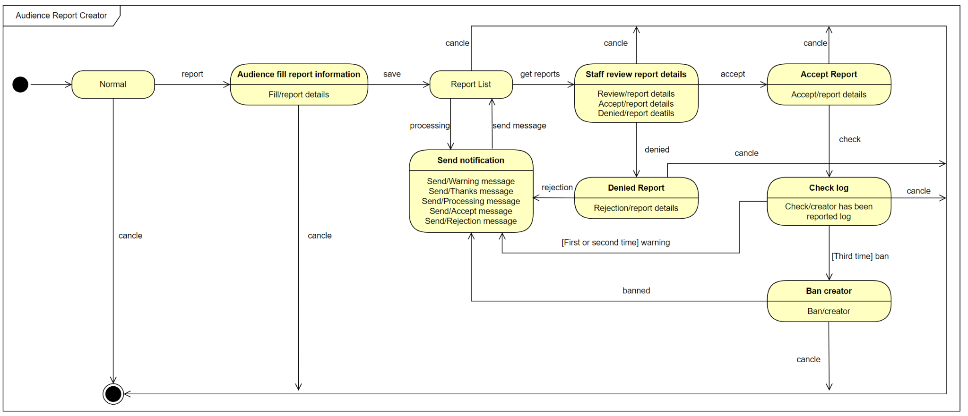

#### 3.4.2 Buy Package

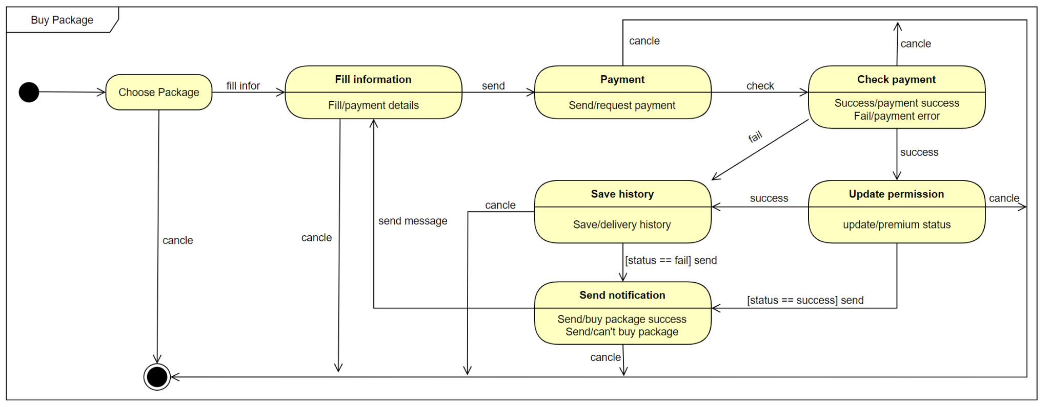

#### 3.4.3 Follow Creator

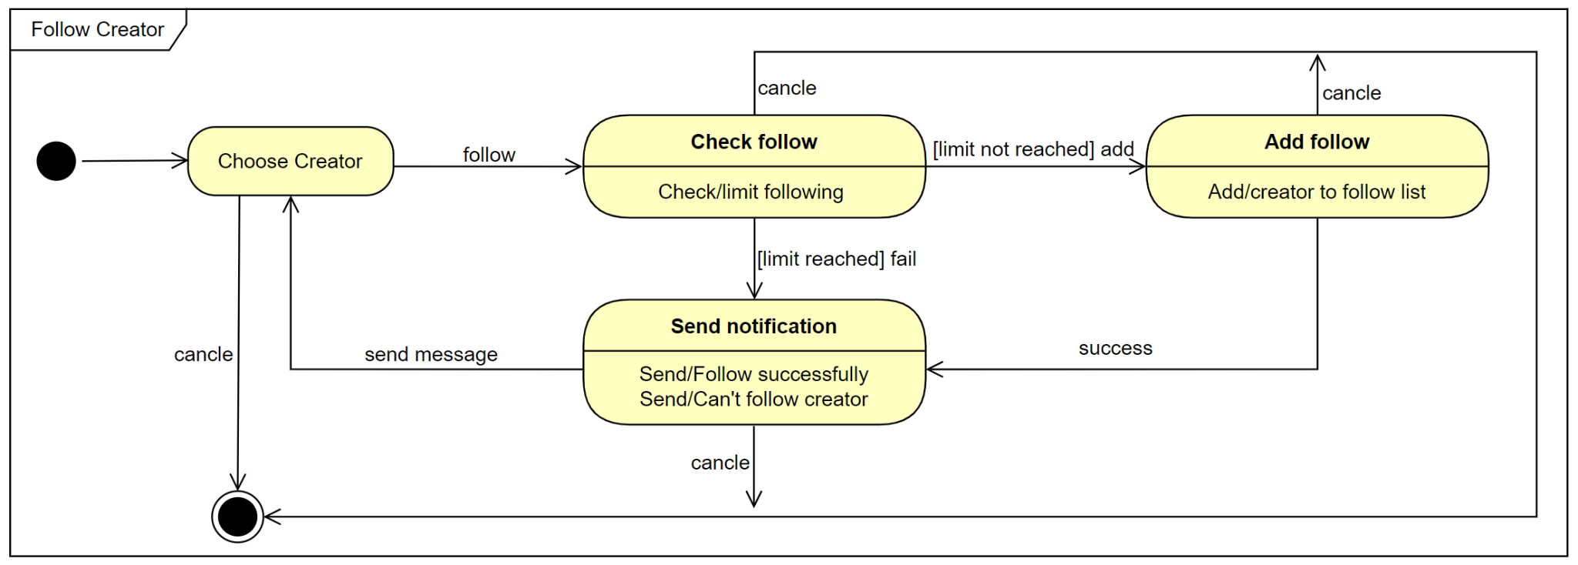

#### 3.4.4 PreOrder Physical Art

